### *Online library Management*

*Submitted in partial fulfillment of the requirements*

*for the award of the degree of*

**Bachelor of Computer Applications**

To

Guru Gobind Singh Indraprastha University, Delhi

Guide: Submitted by:

Ms. Ankita Gupta Chirag 00921102017

(Assistant Professor) Vaibhav 03821102017



**Nurturing Excellence**

**Institute of Information Technology & Management,**

**New Delhi – 110058**

**Batch (2017-2020)**

##### **Certificate**

We, 1. Vaibhav Sethi 03821102017 & 2. Chirag 00921102017 certify that the Summer Training Project Report (BCA-355) entitled “Online library management” is done by us and it is an authentic work carried out by us at Institute of Information Technology and Management .The matter embodied in this project work has not been submitted earlier for the award of any degree or diploma to the best of my knowledge and belief.

1. Signature of the Student 2. Signature of the Student

Date:

Certified that the Project Report (BCA-355) entitled “online library management system”

done by the above students is completed under my guidance.

Signature of the Guide

Date:

Name of the Guide: Ms. Ankita Gupta

(Asst. Prof.

IITM)

Countersigned

Director

**ACKNOWLEDGEMENT**

The success and final outcome of this project required a lot of guidance and assistance frommany people and We are extremely privileged to have got this all along the completion of our

project. All that We have done is only due to such supervision and assistance and I would not

forget to thank them.

We respect and thank for providing an opportunity to do the project work in **IITM** andgiving us all support and guidance, which made me complete the project duly.

We owe our deep gratitude to our project guide **Ms. Ankita Gupta** who took keen interest on our project work and guided us all along, till the completion of our project work by providing all the necessary information for developing a good system.

We are thankful to and fortunate enough to get constant encouragement, support and guidance

from all Teaching staffs which helped us in successfully completing our project work.

Lastly, we would like to thank all those who helped us in any way in our project.

**Vaibhav     03821102017**

**Chirag 00921102017**

|  |  |  |  |  |  |
| --- | --- | --- | --- | --- | --- |
|  | | | | |  |
| |  | | --- | |  | |  |  |  |  |  |

**LIST OF FIGURES**

|  |  |  |
| --- | --- | --- |
| **Figure No .** | **Title** | **Page No.** |
| 1 | Use Case Diagram | 9 |
| 2 | Block Diagram | 13 |
| 3 | Use Case for Admin | 15 |
| 4 | Use Case for Teacher | 16 |
| 4 | Use Case for Student | 16 |

SYNOPSIS

Project title: Library Management System

**INTRODUCTION:**

**Objective:** The objective of the **“Library Management Software”** is to handle the entire activity of a library. The software keeps track of all the information about the books in the library, their cost, their complete details and total number of books available in the Library. The user will find it easy in this automated system rather than using the manual writing system. The system contains a database where all the information will be stored safely. The system is user-friendly and error free.

**Scope:** This project is helpful to track all the book and library information and to rate the maximum number of books, the visitors wished to read. The software will be able to handle all the necessary information.

**PROJECT CATEGORY:**

RDMS

**PROJECT DESCRIPTION:**

The software to be produced is on **Library Management System**. Here there are 2 users. They are The Admin and the receptionist. The first procedure is the registration of the people who arrive to the library. The receptionist has the authority to enter the name, address and contact number of the people who visit the library along with the name of the book they want to read. Their entry and exit time to the library will be noted down. This calculates the total amount of time they spent in library. A library card will also be provided to the customers who visit daily. A person can also borrow the book for particular days. All the information will be entered in the system. If the person doesn’t return the book before the due date, a fine will be added and the information will be sent to that particular person about the fine.

Admin has the authority to add, delete or modify the details of the book available to/from the system. He also has the authority to provide username and password for the receptionist. He can also add the details of the book purchased from shops along with the shop name. Monthly expense report, books purchased report, cash collected for fee can also be viewed.

**Modules of the software:**

* **Books:** Admin has the authority to add, delete or modify the details of the book available to/from the system.
* **Library Registration:** The first procedure is the registration of the people who arrive to the library. The receptionist has the authority to enter the name, address and contact number of the people who visit the library along with the name of the book they want to read.
* **Time spent:** Their entry and exit time to the library will be noted down. This calculates the total amount of time they spent in library.
* **Purchase books:** Admin can also add the details of the book purchased from shops along with the shop name. He also has the authority to delete from or modify it to the database.
* **Borrow books:** A person can also borrow the book for particular days. All the information will be entered in the system. If the person doesn’t return the book before the due date, a fine will be added and the information will be sent to that particular person about the fine.
* **Login registration:** Admin also has the authority to provide username and password for the receptionist.
* **Reports:** Monthly expense report, books purchased report, cash collected for fee can also be viewed.



**HARDWARE REQUIREMENTS:**

* **Processor:** Intel dual core or above
* **Processor Speed:**1.0GHZ or above
* **RAM:** 1 GB RAM or above
* **Hard Disk:** 20 GB hard disk or above

**SOFTWARE REQUIREMENTS:**

* **Language:** Java Application
* **Database:** Mongo DB

**CONCLUSION:**

**Library Management System** allows the user to store the book details and the customer details. This software package allows storing the details of all the data related to library. The system is strong enough to withstand regressive yearly operations under conditions where the database is maintained and cleared over a certain time of span. The implementation of the system in the organization will considerably reduce data entry, time and also provide readily calculated reports.

**CHAPTER- 1**

* 1. **DESCRIPTION OF THE SOFTWARE SYSTEM UNDER STUDY:**

The objective of the **“Library Management”** is to handle the entire activity of a library. The software keeps track of all the information about the books in the library, their cost, their complete details and total number of books available in the Library. The user will find it easy in this automated system rather than using the manual writing system. The system contains a database where all the information will be stored safely. The system is user-friendly and error free. Thisproject is helpful to track all the book and library information and to rate the maximum number of books, the visitors wished to read. The software will be able to handle all the necessary information. The software to be produced is on **Library Management System**. Here there are 2 users. They are The Admin and the receptionist. The first procedure is the registration of the people who arrive to the library. The receptionist has the authority to enter the name, address and contact number of the people who visit the library along with the name of the book they want to read. Their entry and exit time to the library will be noted down. This calculates the total amount of time they spent in library. A library card will also be provided to the customers who visit daily. A person can also borrow the book for particular days. All the 1information will be entered in the system. If the person doesn’t return the book before the due date, a fine will be added and the information will be sent to that particular person about the fine. Admin has the authority to add, delete or modify the details of the book available to/from the system. He also has the authority to provide username and password for the receptionist. He can also add the details of the book purchased from shops along with the shop name. Monthly expense report, books purchased report, cash collected for fee can also be viewed. Library Management Systemallows the user to store the book details and the customer details. This software package allows storing the details of all the data related to library. The system is strong enough to withstand regressive yearly operations under conditions where the database is maintained and cleared over a certain time of span. The implementation of the system in the organization will considerably reduce data entry, time and also provide readily calculated reports. Library Management System involves the following functions (Explained by a use case diagram):

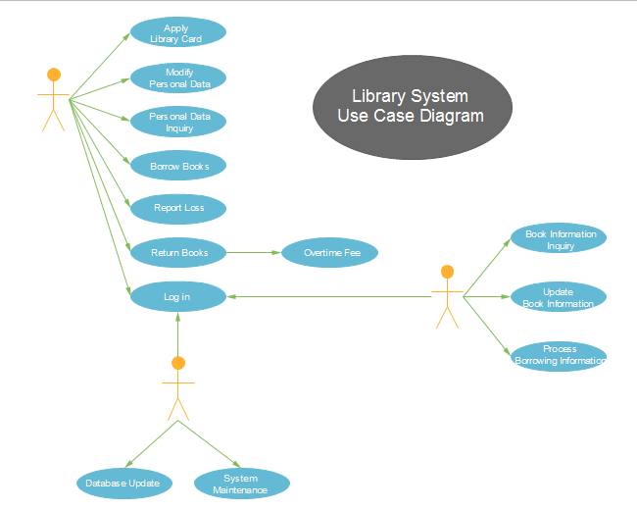

* 1. **DATA COLLECTION**:
* www.w3schools.com
* https://www.edx.org
* http://github.com
* <https://bootstrapmade.com>
  1. **TOOLS / PLATFORMS:** 
     1. Hardware specifications:
* Hard Disk: - 20 GB or above
* Processor: Intel dual core or above
* RAM: - 1 GB or above
* Front end: - Bootstrap, Node js, Angular , JavaScript , CSS , HTML
* Back end: - Mongo Db
  + 1. Software specifications:
* Operating System: - Android version Lollipop (5.1) or above, IOS 12.3 Or above.
* Android Development Toolkit (ADT)
  1. **PROJECT PLANNING**:

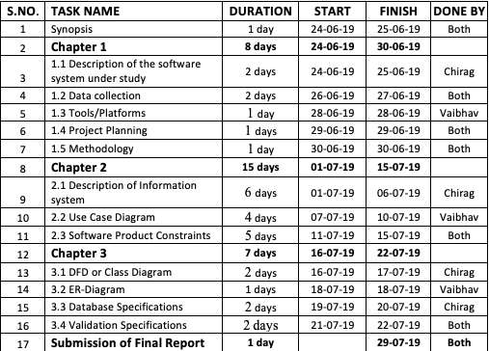

**Problems with Existing System:**

In the existing library management system, users need to waste a lot of time and physical effort in adding new books with there all details. It’s really difficult to find the number of hours spend by a student in library.

**METHODOLOGY:**

**1.5.1. STAGE OF ITERATIVE MODEL:**

**Phases of Life Cycle Model:**

* **Planning and requirement:** All possible requirements of the system to be developed are captured in this phase and documented in a requirement specification document.
* **Analysis and design:** The requirement specifications from first phase are studied in this phase and system design is prepared. It helps in specifying hardware and system requirements and also helps in defining overall system architecture.
* **Implementation:** With inputs from system design, the system is first developed in small programs called units, which are integrated in the next phase. Each unit is developed and tested for its functionality which is referred to as Unit Testing.
* **Testing:** All the units developed in the implementation phase are integrated into a system after testing of each unit. Post integration the entire system is tested for any faults and failures.
* **Evaluation:** This will evaluate the outcome of the processing whether the application is running successfully or not.

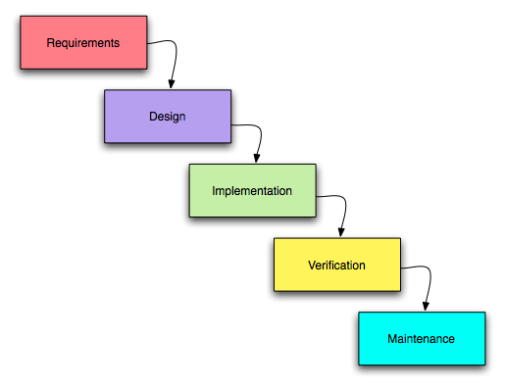

**1.5.2. REASON FOR CHOOSING WATERFALL MODEL :**

* It is very simple to understand and use.
* As we are new to this it is very difficult to analyse all requirements at once. Building the whole application at once is not possible for us.
* So, by dividing the Project into small parts and implementing them makes easy for us to make this application.

**ADVANTAGES OF THIS MODEL:**

* This model is simple and easy to understand and use.
* It is easy to manage due to the rigidity of the model – each phase has specific

deliverables and a review process.

* In this model phases are processed and completed one at a time.

**CHAPTER-2**

**Software Requirement Specification**

**1.1 Introduction**

The following subsections of Software Requirement Specifications Document should facilitate in providing the entire overview of the Information system “Library Management System ” under development.

This document aims at defining the overall software requirements for users. Efforts have been made to define the requirements of the Information system exhaustively and accurately.

**1.2 Purpose**

The main purpose of Software Requirement Specifications Document is to describe in a precise manner all the capabilities that will be provided by the Software Application Library Management System . It also states the various constraints which the system will be abide to. This document further leads to clear vision of the software requirements, specifications and capabilities. These are to be exposed to the development, testing team and end users of

the software.

**2. Description of Information System (Block Diagram):**

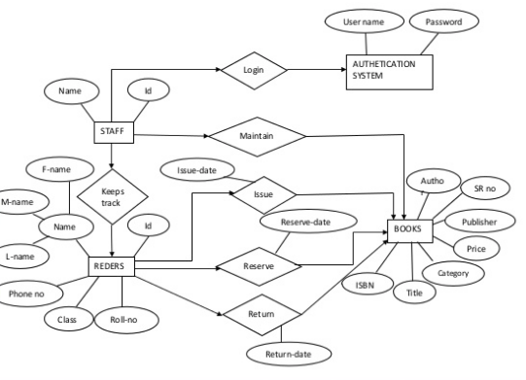

**3. Overview**

The rest of this SRS document describes the various system requirements, interfaces, features and functionality in detail.

**Overall description of proposed system**

**3.1 Perspective**

The application will be windows-based, self-contained and independent software product.

Front End Client Application (with data entry / update /delete /view and reporting facility)

Backend Database

**3.2 System Interfaces**

None

**3.3 Interfaces**

The application will have a user friendly and menu-based interface. Following screens will be provided.

A Login Screen for entering username, password and role will be provided. Access to different screens will be based upon the role of the user.

**4. Input/ Output Data elements:**

**1. Adminlogin:**

|  |  |  |  |
| --- | --- | --- | --- |
| **Field name** | **Data type** | **size** | **Null** |
| username | Varchar | 30 | Not null |
| password | Varchar | 30 | Not null |

**User login:**

|  |  |  |  |
| --- | --- | --- | --- |
| **Filed name** | **Data type** | **Size** | **Null** |
| User name | varchar | 30 | Not null |
| Password | Varchar | 30 | Not null |
| phone no | Varchar | 15 | Not null |
| Email id | Varchar | 30 | Not null |
|  |  |  |  |

**Library information:**

|  |  |  |  |
| --- | --- | --- | --- |
| **Field name** | **Data type** | **Size** | **Null** |
| User name | Varchar | 30 | Not null |
| Id | number | 30 | Not null |
| date/time | Date/time | 30 | Not null |
| User_ name | Varchar | 30 | Not null |
| User_ id | number | 15 | Not null |
| User_ add | Varchar | 50 | Not null |
| User_ contact | number | 15 | Not null |
| Email id | Varchar | 30 | Not null |

**Use Case for Admin**

admin

**Use Case for student:**

Student

**Use Case for teacher:**

TEACHER

**5. Software Product constraints:**

**5.1 Feasibility Analysis:**

After doing the project library management and analysing all the existing required functionalities of the system, the next task is to do the feasibility study for the project. All projects are feasible – given unlimited resources and infinite time

Feasibility study includes consideration of all the possible ways to provide a solution to the given problem. The proposed solution should satisfy all the user requirements and should be flexible enough so that future changes can be easily done based on the future upcoming requirements

**5.2 Economic Feasibility:**

1. The project is economically feasible as it only requires a mobile phone with Android operating system.

2. The application is free to download once released for student and payable for college into Android market.

3. The users should be able to connect to internet through mobile phone and thiswould be the only cost incurred on the project.

**5.3 Technical Feasibility:**

To develop this application, an internet connection, a database server, a web server and software are required. The current project is technically feasible as the application was successfully deployed on Android Emulator.

**Behavioural Feasibility:**

The application is behaviourally feasible since it requires no technical guidance, all the modules are user friendly and execute in a manner they were designed.